1. Idea and Opportunity

Idea: A thought, concept, or suggestion that may solve a problem or satisfy a need.
Opportunity: A real chance to turn that idea into a successful and profitable business.

Difference Between Idea and Opportunity
Aspect | Idea | Opportunity
Meaning | A creative thought or concept | A chance to turn the idea into a viable business
Focus | Solving a problem or meeting a need | Creating value, demand, and profit
Market demand | May or may not have demand | Must have market demand
Timing | Can come at any time | Needs the right time and market conditions
Profit potential | Not always clear | Has income and value potential
Viability | May not be practical | More likely to be practical and profitable
Link with goals | Can come from anywhere | Should match the entrepreneur's goals and vision

Full Explanation
Every business starts with an idea, but not every idea becomes a business. An idea becomes an opportunity only when there is: customer need, right timing, market gap, profit potential and the possibility of creating value

Four Essential Qualities of an Opportunity
- Attractive — It should serve a market big enough to earn profit.
- Timely — It should be needed now, not too early or too late.
- Durable — It should continue for some time and not disappear quickly like a fad.
- Unique — It should create or add value for customers in a distinct way.

Three Ways to Identify an Opportunity

1. Observing Trends
Entrepreneurs watch changes happening around them because trends often create business opportunities. The four important trends are:
Economic Forces
Show where startups should enter or avoid. Example: In a weak economy, people want to save money, so money-saving businesses can grow. Example from lecture: GasBuddy.com
Social Forces
Change people's behavior and priorities.
- aging population
- more workplace diversity
- social network use
- more mobile device use
- greater focus on health and wellness
Technological Advances
New technology creates new industries and products.
- Examples: computer industry, internet, biotechnology, digital photography
- Example from lecture: H20Audio — created waterproof accessories for iPhones
Political and Regulatory Changes
New laws and rules create new needs.
- Example: Environmental laws create opportunities for firms that help others follow regulations.

2. Solving a Problem
Sometimes an opportunity is found simply by noticing a problem and solving it. Many companies start because founders personally experienced a problem and then created a solution. Problems may be discovered through trends, intuition, chance, or change in daily life.

3. Finding Gaps in the Marketplace
A market gap exists when a group of people needs a product or service that is not properly served. Mainstream companies may ignore that group because the segment looks too small or too specialized. For entrepreneurs, that ignored need can become a strong business opportunity.

Personal Characteristics That Help Opportunity Recognition

1. Prior Experience
Work experience helps a person understand an industry deeply, spot unmet customer needs and underserved market niches, and build useful contacts.

2. Cognitive Factors
Some people have strong entrepreneurial alertness — they notice useful opportunities without doing a formal search. It is like a "business sixth sense."

3. Social Networks
People with strong networks hear more ideas and see more opportunities.
- Strong-tie relationships: Close friends, family, and regular contacts. These usually reinforce what we already know.
- Weak-tie relationships: Casual contacts or acquaintances. These often bring fresh ideas and new perspectives.

4. Creativity
Creativity means generating a new or useful idea. Opportunity recognition is partly a creative process.

Five Stages of the Creative Process
- Preparation — Background, knowledge, and experience. The entrepreneur gathers information.
- Incubation — The person keeps thinking about the problem. Ideas "cook" in the mind.
- Insight — The "eureka" moment. The idea or opportunity becomes clear.
- Evaluation — The idea is checked carefully for viability. Many people skip this step and rush too early.
- Elaboration — The idea is shaped into a final form. In a new business, this is where the business plan is written.

Techniques for Generating Ideas

1. Eidetic Image Method
People imagine the problem or product clearly and use that mental image to generate ideas. This helps create creative and specific solutions.

2. Starbursting Method
The main idea is placed in the center of a star. Around it, ask: Who? What? Where? When? Why? How? This method helps examine an idea from all angles.

3. SCAMPER Method
Letter | Stands For | Question
S | Substitute | What can be replaced?
C | Combine | What can be combined?
A | Adapt | What can be added or adjusted from another idea?
M | Modify / Magnify / Minify | What can be changed in size, shape, color, or performance?
P | Put to another use | Can it be used in another way or another industry?
E | Eliminate | What can be removed or simplified?
R | Reverse / Rearrange / Reengineer | What can be flipped, reversed, or reordered?

2. Myths About Entrepreneurship

Entrepreneurship is often misunderstood. These misunderstandings are called myths.

Myth 1: Entrepreneurs are born, not made
Reality: Entrepreneurs are made through learning and experience. Skills like leadership, communication, market analysis, decision-making, and risk management can all be learned through education, experience, and practice.

Myth 2: Entrepreneurs are gamblers
Reality: Entrepreneurs take calculated risks, not blind risks. Gamblers depend mostly on luck. Entrepreneurs study the situation, estimate possible outcomes, and then take a planned risk — reducing uncertainty through research and testing.

Myth 3: Entrepreneurs work alone
Reality: Successful entrepreneurs depend on teams, contacts, mentors, and networks. They need skilled employees, partners, advisors, investors, suppliers, and customers. Team building is a major part of success.

Myth 4: A good idea is enough
Reality: A good idea must also have market demand, proper timing, good execution, customer value, and a workable business model. Many good ideas fail because execution is poor.

Myth 5: Success comes quickly
Reality: Entrepreneurship takes time, effort, setbacks, and persistence. Startups usually face mistakes, competition, delays, financial pressure, and learning curves. Real success often comes after repeated improvement and patience.

3. Feasibility Analysis

What is Feasibility Analysis?
Feasibility analysis is the process of checking whether a business idea is practical and worth pursuing. It is:
- a preliminary evaluation
- done before writing a business plan
- used to reduce guesswork
- used to judge whether an idea is viable

Timing of Feasibility Analysis
💡 Memory Trick: Opportunity first → Feasibility second → Business plan third.

Four Forms of Feasibility Analysis
💡 Memory Trick: P-I-O-F: Product/Service → Industry/Target Market → Organizational → Financial

1. Product/Service Feasibility
Checks whether the proposed product or service is realistic and likely to succeed in the market. It looks at: market demand, competition, regulatory considerations, technical feasibility, and practical success potential.
Key Questions
- Do customers really want it?
- Is there enough demand?
- Are competitors already strong?
- Can the product be developed properly?
- Can legal and technical requirements be met?
Example: XYZ HealthTech (Telemedicine Platform)
Area | What Was Examined
Market Demand | Patient/doctor interest, demographics, healthcare trends, user adoption
Competition | Similar services, strengths/weaknesses, pricing, market share, differentiation
Regulatory | Patient privacy, data security, medical licensing, telehealth regulations
Technical | Software, IT infrastructure, compatibility, scalability, cybersecurity

2. Industry/Target Market Feasibility
Checks the attractiveness of the industry and the specific market segment the business wants to serve.
 | Industry | Target Market
Definition | All firms making similar products or services | The specific group of customers to serve
Scope | Broad — the whole sector | Narrow — a specific niche
Key Factors | Market size, growth, competition, barriers, regulations | Segment size, purchasing power, accessibility, needs
Example — Electric Vehicles: Attractive due to rising demand, government support, better battery technology, and environmental awareness. Challenges include high capital needs and competition from large companies.

3. Organizational Feasibility
Checks whether the business has the internal ability to launch and run successfully.
- Management Expertise — Does the team know the market, product, and strategy?
- Organizational Structure — Are roles, departments, and decision-making clear?
- Human Resources — Are enough skilled workers available?

4. Financial Feasibility
Checks whether the business idea makes financial sense and whether expected returns justify the investment.
Factor | Description
Revenue Projections | How much money can the business earn?
Cost Estimates | What will it cost to develop, launch, and run?
Funding Requirements | How much money is needed and where will it come from?
Cash Flow Projections | When will cash come in and go out? Can the firm pay bills on time?
Return on Investment | Is the project worth the investment? (Payback period, NPV, IRR)
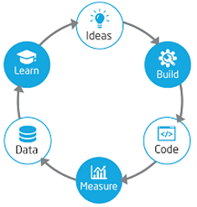
4. Build-Measure-Learn Cycle

Startup Meaning The Lean Startup methodology was developed by Eric Ries. It is a way of building startups through continuous innovation, validated learning, and rapid iteration.

The Three Steps
Step | Action | Key Concept
1. Build | Create a simple version of the product | MVP = Minimum Viable Product — simplest version, built with least effort, maximum learning
2. Measure | Collect real data from users and the market | Track: sign-ups, feedback, sales, usage, retention, adoption
3. Learn | Understand what the data means | Decide: Persevere (keep going) or Pivot (change direction)

Related Lean Startup Principles
Principle | Meaning | Example
Validated Learning | Learn from experiments and real data, not assumptions | Airbnb tested by offering air mattresses during a conference
MVP | Minimum version to test the idea with customers | Tesla's Roadster was an early MVP before larger expansion
Continuous Deployment | Release improvements frequently | Facebook regularly updates features based on user data
Pivot or Persevere | If weak results → pivot. If strong results → continue | Instagram started as Burbn (location app), pivoted to photo sharing
Fail Fast, Fail Cheap | Test quickly and cheaply. Treat failure as learning | Many successful startups had multiple failed iterations first
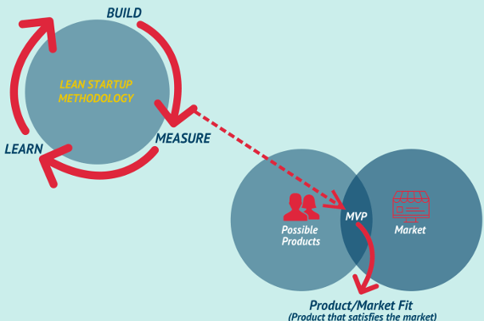
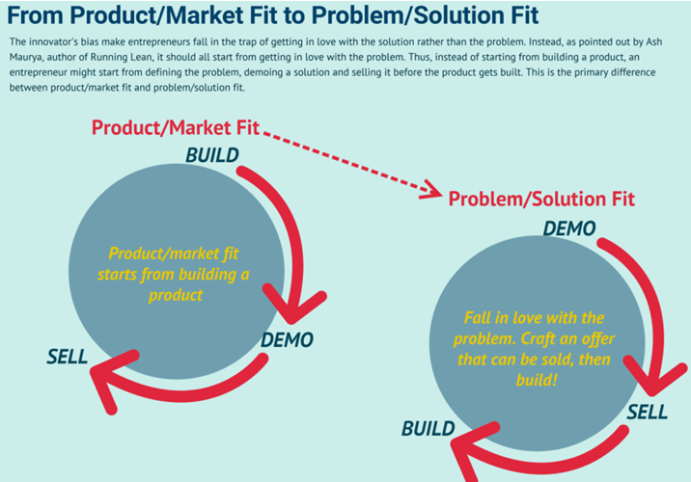

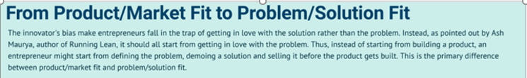

What is the Build-Measure-Learn Cycle?
The Build-Measure-Learn cycle is the core cycle of the Lean Startup approach.
Instead of building a full product first and hoping it works, the startup:
- Builds a basic version
- Measures how users respond
- Learns from the results
- Improves, repeats, or changes direction

Minimum Viable Product (MVP)
A **minimum viable product** is the version of a new product that allows a team to collect the **maximum amount of validated learning about customers with the least effort**.
In simple words, it is the smallest workable version of a product used for testing.
- Its purpose is not to be perfect.
- Its purpose is to learn what customers actually want.
Important lecture point: The MVP works through the Build-Measure-Learn cycle. This cycle is the foundation of Lean Startup methodology.

Product/Market Fit vs Problem/Solution Fit

Traditional Product/Market Fit
- Build the product first
- Then test it again and again to find market fit
- The entrepreneur starts by building something and then tries to discover whether the market really wants it
**Simple flow: Build → Demo → Sell**

Meaning of Product/Market Fit
Product/market fit means the product satisfies a real market need. It means the business has created something people actually want, use, and are willing to pay for.

Lean Startup Problem/Solution Fit (Market First)
- Validate demand first
- Then build more confidently
- Start by understanding the problem, not by falling in love with the solution
- Create an offer or demo that can be sold before the full product is built
**Simple flow: Demo → Sell → Build**

Market First
Market First means:
- First understand the customer's problem
- Then create a demo or simple offer
- Then test whether people are willing to buy
- And only after validation, build the full product
This approach reduces waste because the business does not spend too much time and money building something the market may reject.

Core Difference Between the Two Approaches
Approach | Starting Point | Flow | Main Idea
Product/Market Fit | Product | Build → Demo → Sell | Build first, then search for the market
Problem/Solution Fit / Market First | Problem | Demo → Sell → Build | Validate the market first, then build

⭐ Very Important Exam Point
- In product/market fit, entrepreneurs may become too attached to the product or solution first.
- In problem/solution fit, entrepreneurs focus first on the customer's problem.
- Lean Startup prefers starting with the problem, testing a demo, and checking if it can be sold before full development.
Example: Tesla often demonstrates and pre-sells cars before large-scale production.

How MVP Connects to Product/Market Fit
- A startup may have many possible product ideas.
- The market has real needs and demands.
- The MVP is used to test whether one of those product ideas actually fits the market.
- When the MVP satisfies a real need, the startup moves closer to product/market fit

Famous MVP Examples
Company | MVP | Learning
Airbnb | Renting out air mattresses and offering breakfast | People were willing to pay for temporary accommodation
Dropbox | A simple video demo | Users were interested before the full product was built
Facebook | Network only for Harvard students | The model could expand to other universities and then globally
Instagram | Burbn app (location-based) | Pivoted to photo sharing based on what users actually used
Uber | Simple black-car app for a small group | Proved demand for on-demand rides
Spotify | Launched in Sweden with limited catalog | Validated streaming music model

5. Porter's Five Forces

Introduction
Porter's Five Forces model was created by Michael Porter and first published in 1979. It is a framework used to study the competitive pressure inside an industry and helps businesses understand how attractive an industry is, how strong competition is, and how easy or difficult it will be to earn profit.

💡 Memory Trick: Stronger forces = Lower profitability. Weaker forces = Better profitability.

The Five Forces
Force | Meaning | High When... | Lecture Example
1. Threat of New Entrants | How easy it is for new companies to enter the industry | Low capital requirements, weak brand loyalty, few regulations | Airline industry — high capital, many regulations → difficult entry
2. Bargaining Power of Suppliers | How much power suppliers have over businesses | Few suppliers, unique inputs, hard to switch, heavy dependence | Smartphones — depend on processors and displays from few suppliers
3. Bargaining Power of Buyers | How much power customers have over businesses | Many alternatives, easy price comparison, low switching cost | Retail — customers compare prices online easily
4. Threat of Substitutes | Danger that another product may satisfy the same need differently | Alternatives are available, convenient, cheaper or better | Music industry — streaming (Spotify) replaced CDs and downloads
5. Intensity of Rivalry | How strongly existing firms compete against each other | Many strong competitors, slow growth, similar products, high exit barriers | Soft drinks — Coca-Cola vs Pepsi constant competition

6. Business Plan

What is a Business Plan?
A business plan is a comprehensive written document that explains a business idea and how the business will operate, grow, and succeed. It includes goals, strategies, operations, financial details, and plans for the future.

Why a Business Plan is Important
- Acts as a roadmap for the business
- Helps entrepreneurs think clearly
- Helps attract investors, lenders, and partners
- Ensures important parts of the business are planned carefully
- Turns a business idea into a structured action plan

Nine Main Parts of a Business Plan
Part | Contents
1. Executive Summary | Short overview — concept, goals, and major highlights
2. Company Description | Mission, vision, legal structure, location, business background
3. Market Analysis | Industry research, target market, customer demographics, competition, trends
4. Organization and Management | Organizational structure, key people, roles and responsibilities
5. Product or Service Line | What the business offers, features, benefits, unique selling points
6. Marketing and Sales Strategy | How customers will be reached, pricing, promotion, distribution, sales methods
7. Funding Request | How much money is needed, where it will be used, possible sources of finance
8. Financial Projections | Expected performance, income statements, cash flow, balance sheets, profitability
9. Appendix | Supporting documents: resumes, research data, legal papers, technical details

Business Plan vs Business Model
Aspect | Business Plan | Business Model
Meaning | Full written document | Framework for how value is created, delivered, and captured
Focus | Overall strategy, operations, and finance | Core logic of making money and sustaining the business
Nature | More detailed and formal | More conceptual and flexible
Main question | How will the business run and grow? | How will the business create and capture value?
Audience | Mostly investors, lenders, stakeholders | Internal and external stakeholders
Change | Relatively static, updated when needed | More dynamic and adaptable

12 Investor Presentation Slides (FYP)
When presenting the business plan to investors, founders should prepare 12 PowerPoint slides:
# | Slide | Key Content
1 | Title Slide | Company name, founders' names, company logo (if available)
2 | Problem | Briefly explain the problem to be solved or the need to be filled
3 | Solution | How the business will solve the problem and satisfy the need
4 | Opportunity & Target Market | Specific target market and trends creating the opportunity
5 | Technology (optional) | Explain the technology or unusual aspect simply and interestingly
6 | Competition | Firm's competitive advantage and how it will compete against established rivals
7 | Marketing and Sales | Overall marketing strategy, sales process, primary research results
8 | Management Team | Current team, how they came together, qualifications, board of advisors
9 | Financial Projections | How the firm achieves profitability, capital needed, cash flow break-even
10 | Current Status | Current stage of the venture and milestones achieved so far
11 | Financing Sought | How much financing is requested and exactly how it will be used
12 | Summary | Strongest points of the venture and team — invite questions

